PRROGRAM USER GUIDE

Getting Started:
Currently, you must have the following files:
- ChatClient.java
- ChatServer.java
- ListenerTask.java

Server:
Now, you need to run the server, make a note of what port number is hard-coded in, you’ll need this for launching the client.
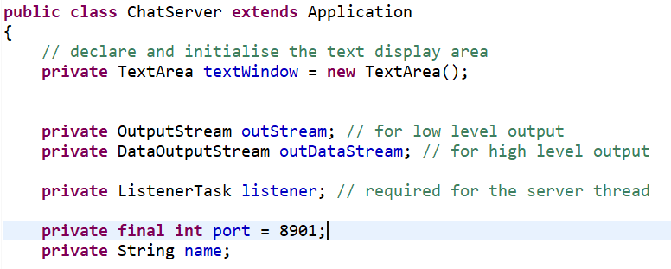
[Figure 2.1- The Port Number]
When launching, you will see a prompt window asking for your username, this can be whatever you like, for the purpose of this exercise we will use the name “User1”.
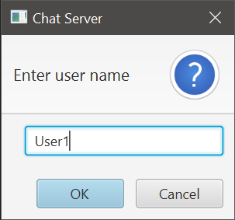
[Figure 2.2 – User Name Window]
Proceed to click ‘ok’ and ‘ok’ again when the next prompt comes up. We now wait for a client to connect.

Client:
Run the client program, the following window will appear, asking for a remote host. This is where the IP for the server is entered.
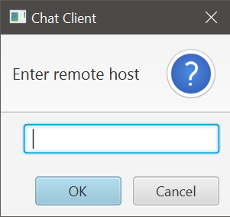
[Figure 3.1 – Remote Host Entry]
Since I am running these programs on my host OS, use the IPCONFIG command for windows (Or IFCONFIG for most linux distros) to find your IP.
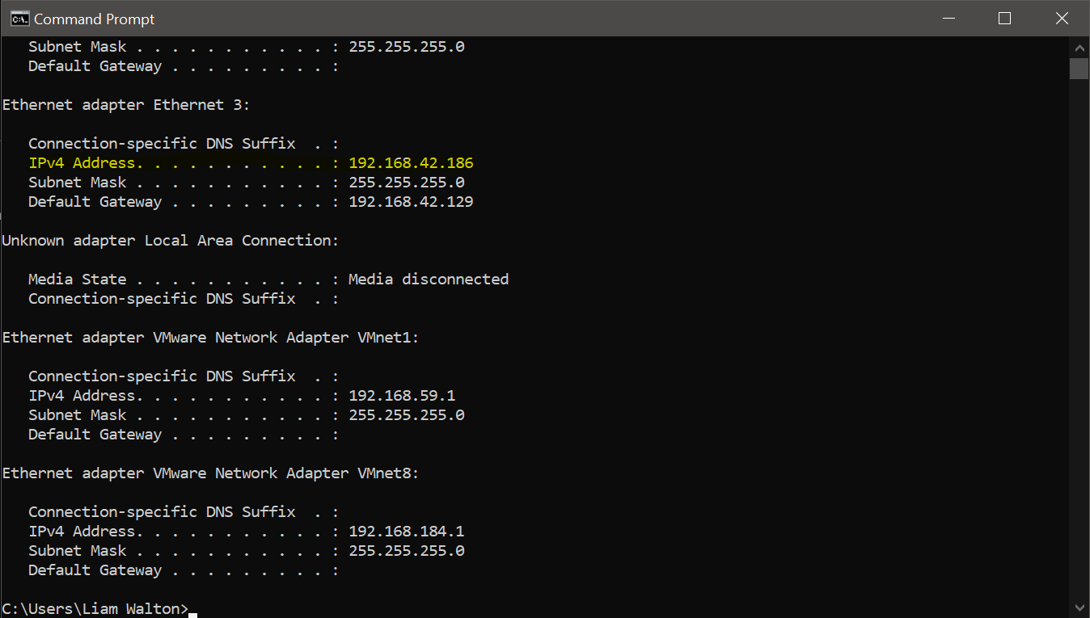
[Figure 3.2 – Finding the Server IP]
Once you have entered the IP, proceed then enter in the port number we noted earlier, enter in your username, here we will user User2.
Now, since I have launched both applications I will have 2 windows appear on my screen, one from User1, and one from User 2. Simply type a message in the text box and hit enter to send.
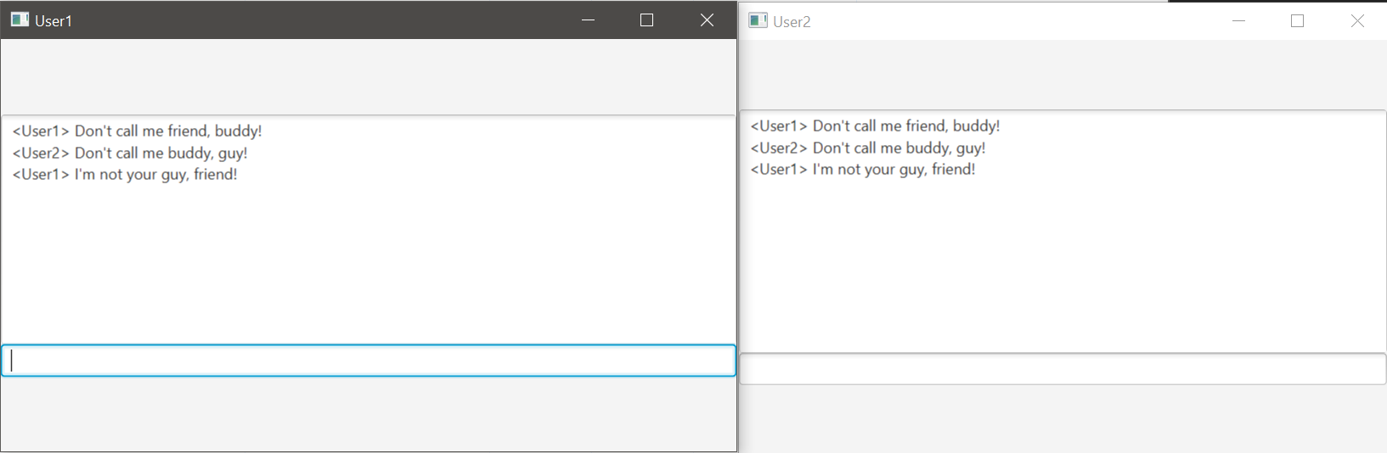
[Figure 3.3 – The Final Result]

